Strassen’s Matrix Multiplication:
Task9:
class Solution {
public int[][] matrixBlockSum(int[][] mat, int k) {
int m = mat.length;
int n = mat[0].length;

int[][] prefix = new int[m + 1][n + 1];
int[][] answer = new int[m][n];

// Build prefix sum
for (int i = 0; i < m; i++) {
for (int j = 0; j < n; j++) {
prefix[i + 1][j + 1] =
mat[i][j]
+ prefix[i][j + 1]
+ prefix[i + 1][j]
- prefix[i][j];
}
}

// Calculate each block sum
for (int i = 0; i < m; i++) {
for (int j = 0; j < n; j++) {

int r1 = Math.max(0, i - k);
int c1 = Math.max(0, j - k);

int r2 = Math.min(m - 1, i + k);
int c2 = Math.min(n - 1, j + k);

answer[i][j] =
prefix[r2 + 1][c2 + 1]
- prefix[r1][c2 + 1]
- prefix[r2 + 1][c1]
+ prefix[r1][c1];
}
}

return answer;
}
}
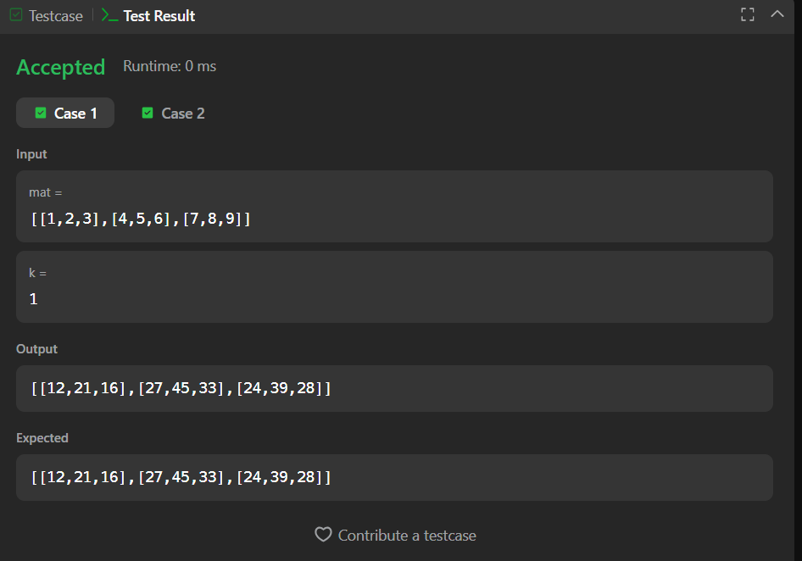
Task10:
import java.io.*;
import java.util.*;

public class Solution {

public static void matrixRotation(List<List<Integer>> matrix, int r) {
int m = matrix.size();
int n = matrix.get(0).size();

int[][] a = new int[m][n];

for (int i = 0; i < m; i++) {
for (int j = 0; j < n; j++) {
a[i][j] = matrix.get(i).get(j);
}
}

int layers = Math.min(m, n) / 2;

for (int layer = 0; layer < layers; layer++) {

int top = layer;
int left = layer;
int bottom = m - 1 - layer;
int right = n - 1 - layer;

ArrayList<Integer> elements = new ArrayList<>();

// Top row: left -> right
for (int j = left; j <= right; j++) {
elements.add(a[top][j]);
}

// Right column: top+1 -> bottom
for (int i = top + 1; i <= bottom; i++) {
elements.add(a[i][right]);
}

// Bottom row: right-1 -> left
for (int j = right - 1; j >= left; j--) {
elements.add(a[bottom][j]);
}

// Left column: bottom-1 -> top+1
for (int i = bottom - 1; i > top; i--) {
elements.add(a[i][left]);
}

int len = elements.size();
int shift = r % len;

int index = 0;

// Top row
for (int j = left; j <= right; j++) {
a[top][j] = elements.get((index + shift) % len);
index++;
}

// Right column
for (int i = top + 1; i <= bottom; i++) {
a[i][right] = elements.get((index + shift) % len);
index++;
}

// Bottom row
for (int j = right - 1; j >= left; j--) {
a[bottom][j] = elements.get((index + shift) % len);
index++;
}

// Left column
for (int i = bottom - 1; i > top; i--) {
a[i][left] = elements.get((index + shift) % len);
index++;
}
}

// Print result
for (int i = 0; i < m; i++) {
for (int j = 0; j < n; j++) {
System.out.print(a[i][j]);

if (j < n - 1) {
System.out.print(" ");
}
}
System.out.println();
}
}

public static void main(String[] args) {
Scanner sc = new Scanner(System.in);

int m = sc.nextInt();
int n = sc.nextInt();
int r = sc.nextInt();

List<List<Integer>> matrix = new ArrayList<>();

for (int i = 0; i < m; i++) {
List<Integer> row = new ArrayList<>();

for (int j = 0; j < n; j++) {
row.add(sc.nextInt());
}

matrix.add(row);
}

matrixRotation(matrix, r);

sc.close();
}
}